Project 2

USA consumer forum Data Analysis

Task 1:

Loading the data into Pig Relation



Dumping the result of A

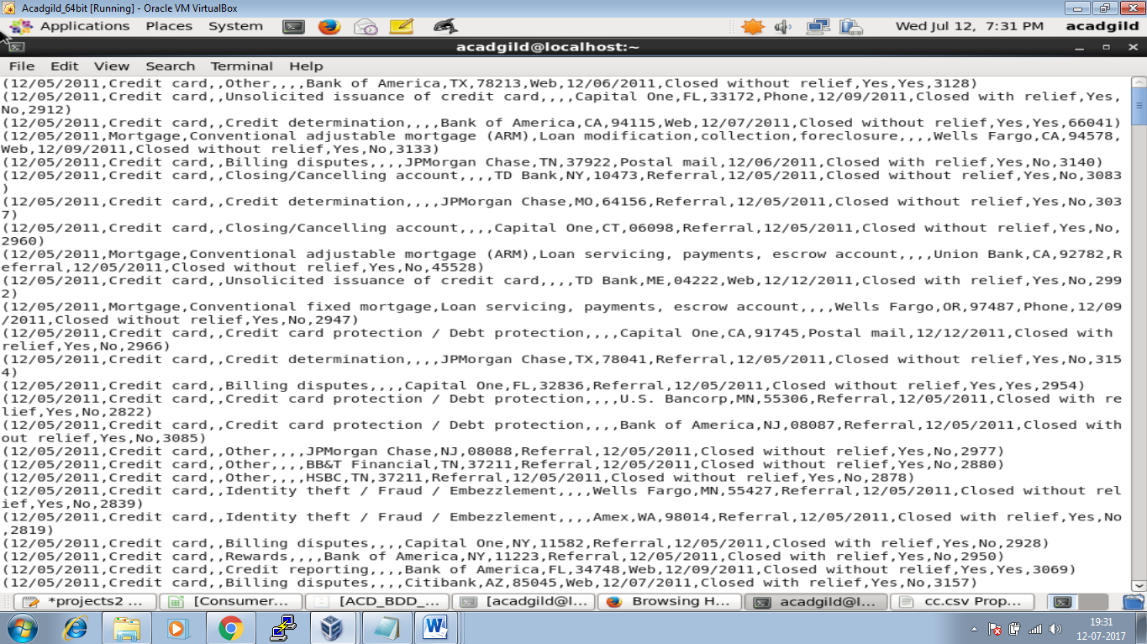



Dumping the Result of B

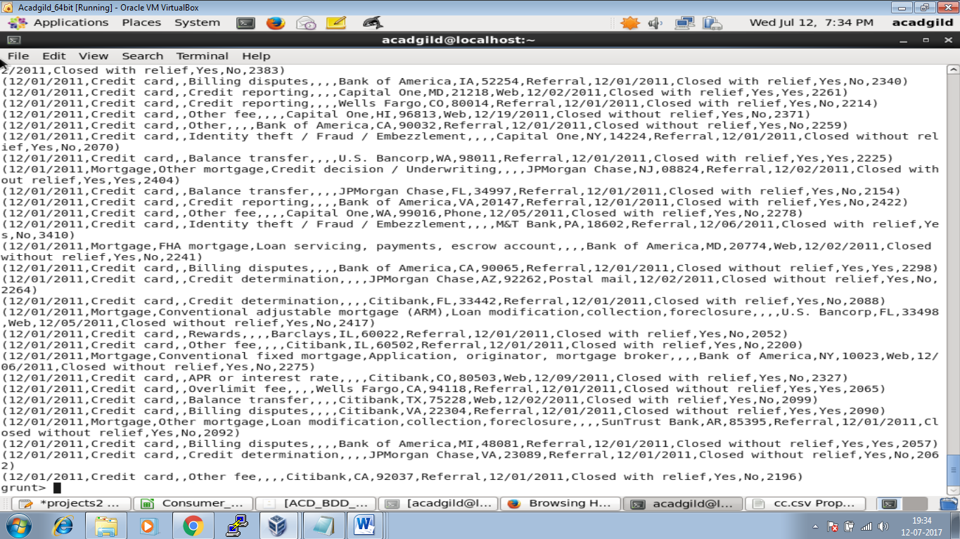



Dumping the result of C

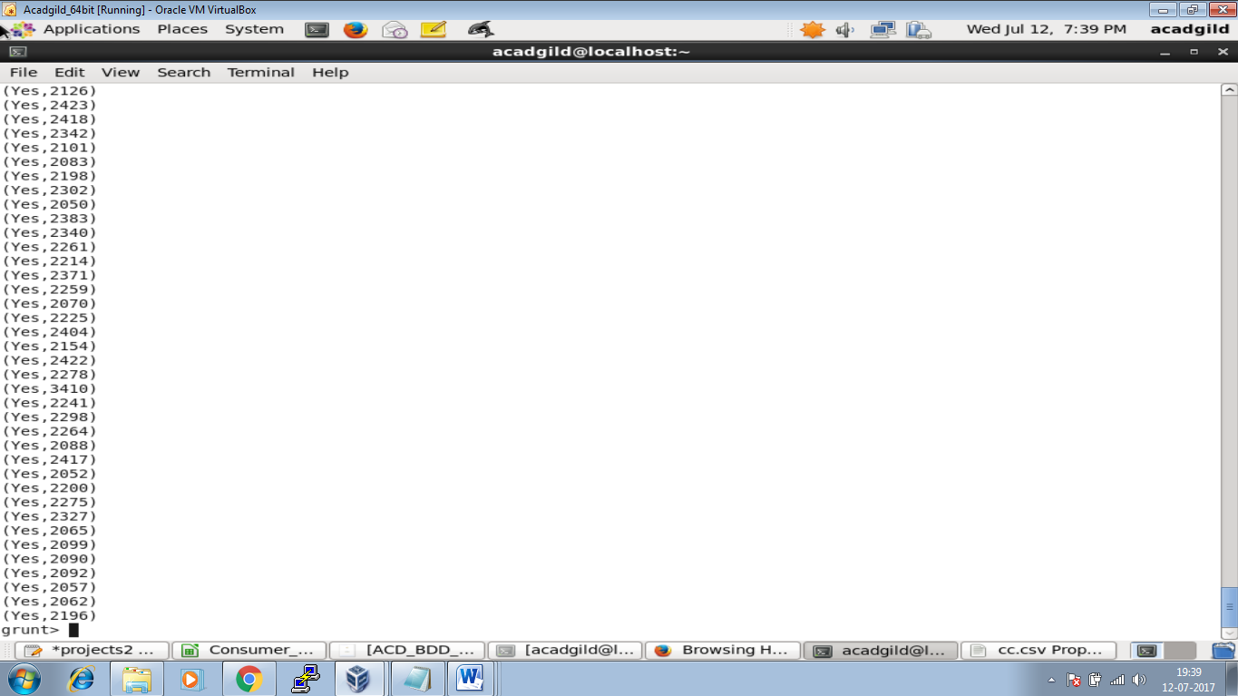



Dumping the Result of D

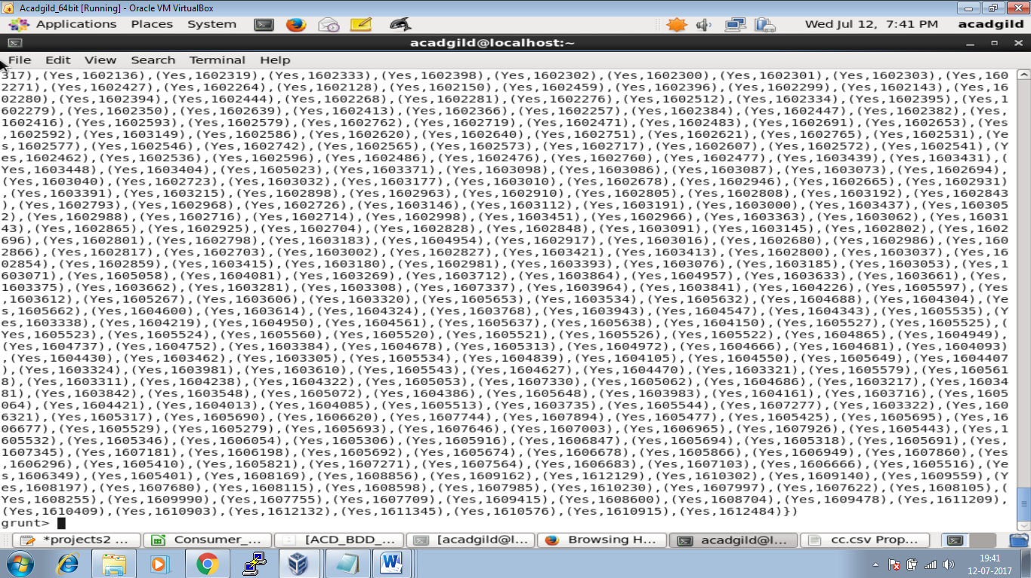



Dumping the result of E

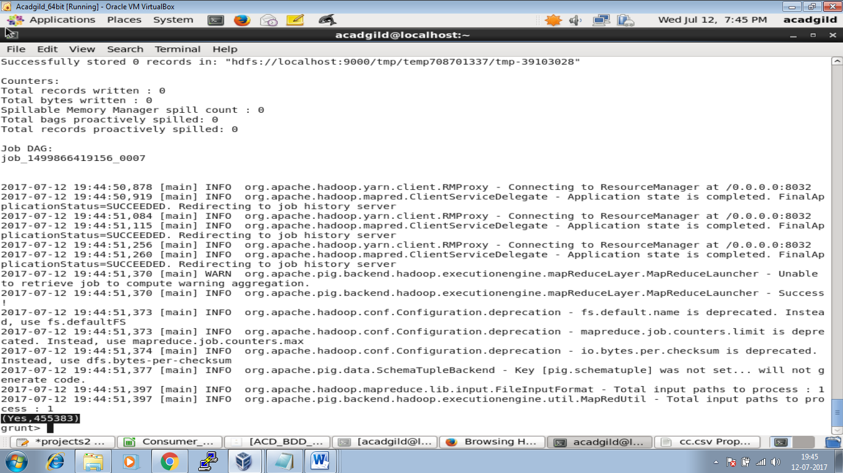

Storing the result

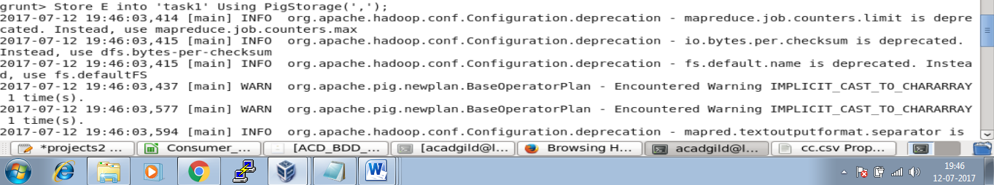

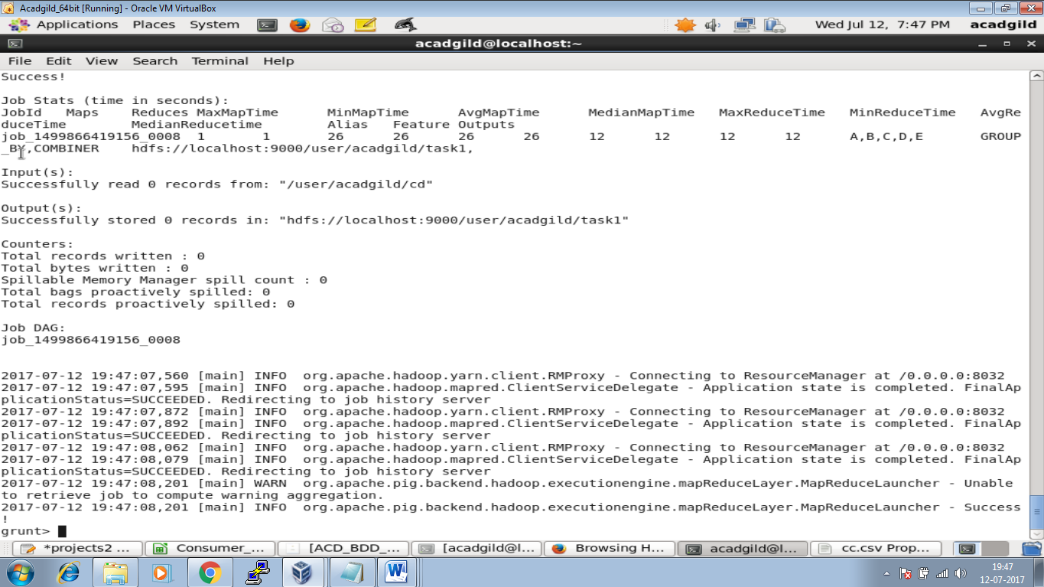

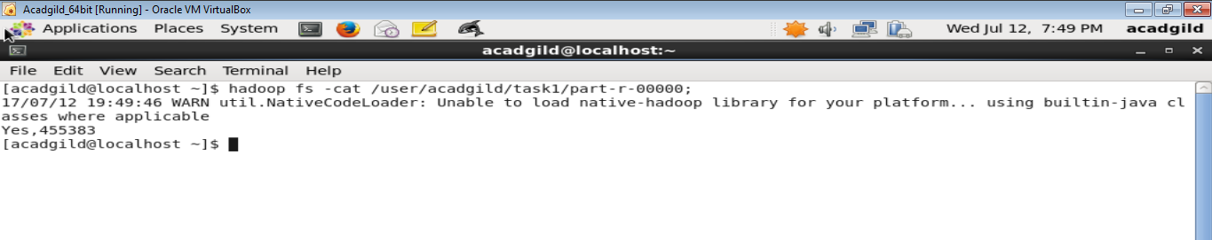

Creating the table in Mysql.

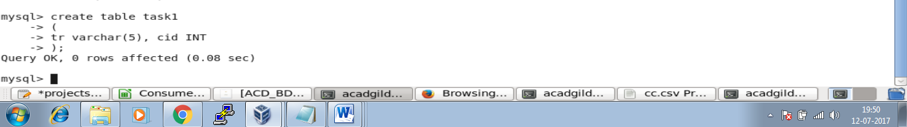

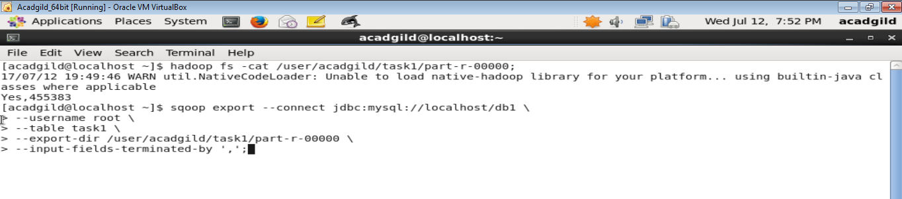

Final Output

